Current Market View – June 2026
Investment Markets
Global Markets
Global equities in June 2026 were essentially flat, with headline indices masking significant rotation beneath the surface. Markets were shaped by a sharp collapse in oil prices, a cooling of AI-related exuberance, particularly around hyperscaler spending and a more hawkish stance from major central banks that recalibrated expectations for both inflation and growth. Semiconductor strength contrasted with weakness in commodity-linked sectors, while investors reassessed the sustainability of recent tech-driven market leadership. Overall, June functioned as a transition month defined by volatility, shifting narratives, and a broad rebalancing of risk appetite.
In fixed income, global bond yields generally drifted lower as the oil-price shock fed disinflation expectations. Still, the U.S. front end moved higher after the Federal Reserve removed its easing bias. This divergence created a mixed backdrop for duration assets, with long-end bonds benefiting from softer inflation signals. At the same time, short-dated U.S. yields tightened financial conditions and weighed on growth-sensitive equities. Credit markets were largely stable, supported by strong corporate balance sheets and still-solid demand for yield, though spreads widened modestly in commodity-exposed sectors. The overall fixed-income environment reflected a market adjusting to lower inflation and firmer policy stances, an unusual combination that kept rate volatility elevated.
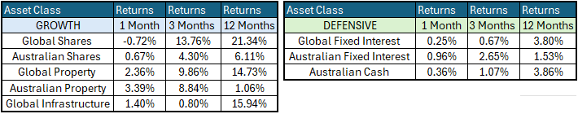
Global Share Markets
Global equities in June 2026 were broadly flat to slightly negative, with the World Index slipping about -0.7%. This was due to the hyperscalers (Amazon, Alphabet, and Microsoft) showing share price weakness following questions about the near-term return on massive AI infrastructure spending, which is currently being fueled by large amounts of private debt. The month also featured historic corporate actions, including Alphabet’s $85B equity offering and the SpaceX IPO at a valuation of US$1.78T, both of which amplified volatility.
Regionally, performance diverged sharply. The United States saw modest declines as mega-cap tech lost more than $2T in market value, even though semiconductors and memory stocks posted double-digit gains. Europe outperformed thanks to lower energy costs and resilient earnings momentum. Japan delivered strong gains driven by semiconductor strength and yen weakness, though volatility was extreme. The UK eked out slight gains but was held back by commodity sectors and political uncertainty. Australia posted modest gains, with industrials, healthcare, and consumer stocks outperforming, while resources fell alongside oil, gold, and copper. China declined amid weak consumption, property-sector stress, and fragile business confidence. Emerging markets softened overall due to profit-taking and AI-related volatility in Korea and Taiwan, while India rose 2.75%, reclaiming its position as the world’s fifth-largest equity market.
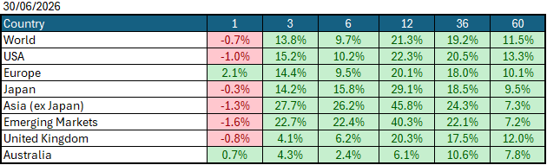
Data Source: AFM as of June 30, 2026.
Global Bond Markets
Global bond yields largely remained flat over the month of June, as inflation fears eased due to peace in the Middle East, which drove down oil prices. This positive inflation development was at odds with the new Federal Governor Walsh's interpretation that the US economy is running too hot and that inflation needs to be reeled in. Yields remain higher across the board year to date, as elevated fuel prices heighten fears of even higher inflation and cash rates ahead.
Interest rate markets were lower in June, with the US 10-year Government bond rate dropping to 4.3626% and the UK 10-year Gilts falling to 4.949% from 5.048% in May 2026.
Domestic Bond Markets
Treasury yields fell across all maturities in Australia as markets started to decrease the number of interest rate hikes by the Reserve Bank this year. This was driven primarily by a weaker inflation rate, which decreased to 4.3% from 4.0%. In Australia, the latest unemployment rate (year-on-year) for May 2026 decreased to 4.5%, down from 4.5% in April. The RBA board is set to meet on the 10th/11th August 2026, with the market half-pricing a +25bps rate hike to 4.60%.
Investment Climate
U.S. equities posted a slightly down month for June 2026 as investors stepped back from the aggressive positioning that dominated early-year trading and shifted toward balance-sheet strength, cash-flow visibility, and defensiveness. This was driven primarily by the -20% fall in the oil price, more questions about expected returns on AI-related capital investment, and a more hawkish sentiment coming from the US Federal Reserve following a higher inflation print during the month. The US earnings season begins in July, which will provide the market with a clearer understanding of how the underlying economy is operating.
Over the medium term, investors are encouraged by the anticipated productivity benefits from AI and the hyperscalers' investments in AI. However, with the unsettled nature of the bond markets due to the war in Iran, the short term has put the handbrake on the level of encouragement. If the US changes its tone and begins raising interest rates under its new Federal Chairman, Kevin Warsh, the medium term could become much less encouraging.
Long-term investors are cautiously optimistic about a recovery period ahead. Global central banks continue to signal their resolve to bring inflation under control; however, economic data show signs of stabilisation despite elevated inflation, which could prompt central banks to raise interest rates in 2026.
The following commentary is based on month-end closing prices as of June 30, 2026:
Global share markets were mostly weaker in June, except in Australia and Europe, where these markets have less exposure to global technology players. Investors continue to believe that geopolitical events in the Middle East will come to an end shortly, with oil falling substantially over the month, bringing hope that inflation will subside shortly. The AUD/USD weakened substantially following changes in US interest rate expectations from 0.7184 to 0.692 (-3.7%).
The U.S. Fed held the federal funds rate target range at 3.50%-3.75% when it met on the 16th/17th June 2026. Last month, the rhetoric of a soft landing came under pressure amid the expected rise in inflation following the oil price spike's impact on food prices, bringing the chances of a rate hike in the US back into focus. The next Fed meeting is on the 28th/29th July 2026.
The underlying short-term theme is "mildly cautious" for shares.
The situation in the Russia/Ukraine conflict remains unchanged, with the latest conflict between Israel and Gaza (Hamas) remaining unchanged as well. Volatility and risk increased as the USA/Israel moved towards a war with Iran.
Investor Focus
For Australia, investors focused on the following issues:
- Cost of living expenses and the impact on consumer spending.
- Commodity prices (post-China policy changes) and the impact on company profits.
- The level of interest rates and the delicate position of the RBA, given the global volatility in markets.
- Rising Oil Prices as conflicts with Iran re-escalate
- U.S. tariffs and the impact on Australia's exports (if any).
- Inflation (year-over-year) increased to 4.6% in the March quarter, with the next quarterly CPI being released on July 29, 2026.
- Government spending and the rising debt level.
Currency
The Australian Dollar closed weaker, AUD/USD 0.692 at the end of June 2026, down from 0.7184 in May. As the Aussie dollar is a 'risk currency', it always sells off during global crises, as we saw in March, regardless of local conditions. June marked the first month of a new Federal Reserve governor, with Walsh’s assessment of the economy changing interest rate expectations in the US from 3 cuts this year to no more cuts. This was in combination with a softer-than-expected inflation print in Australia, which saw the dollar sell off aggressively over the month.
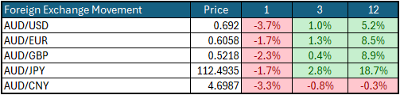
Currency forecasters see the AUD/USD range between:
0.65 and 0.75 cents in the medium term and most likely to trade within the:
0.5500 to 0.7500 range in the longer term.

Australian Economy
Australia's latest GDP data for the first quarter of 2026 showed an annual growth rate of 2.5%, marginally down from 2.6% in the final quarter of 2025. Unemployment decreased marginally in May to 4.4%, down from 4.5% in April 2026. The year-over-year (Y-O-Y) inflation rate decreased to 4.0%, down from 4.0% in May 2026, but remains outside the Reserve Bank's targeted 2% to 3% inflation range and could prompt another rate hike later this year.
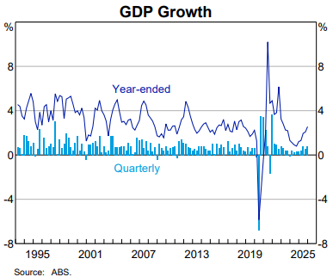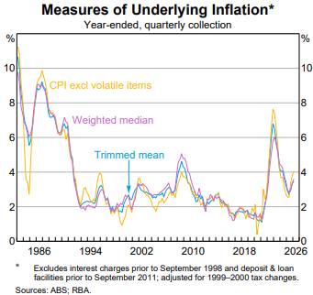

Current Market View

Domestic View
The overall investment view for shares is "cautious" over the short term, "cautiously optimistic" over the medium term, and "long run" as corporate profits continue to grow faster than inflation and as the need to build out data centres drives commodity prices higher.
The market is currently pricing in a half an interest rate hike on the 10th/11th of August 2026, due to a "hotter" inflation print in June that showed inflation is now outside the RBA's target range of 2-3%, in combination with increases in food inflation to increase inflation over the short-term.

Global View
The global share market remains cautious, aside from a few AI companies, amid the looming threat of a global inflation spike that could force many economies to raise interest rates. Given the current tensions in the Middle East, we could see a global slowdown in GDP growth, as energy production cannot keep pace with the rollout of AI data centres.

Where to From Here?
- Continued shift from rules-based order and win-win multilateral trade to power-based order and win-lose trade deals. Trump did not start this. The shift started in the 2010s with the U.S./Europe letting Putin take Crimea in return for cheap gas for Germany/Europe, and the U.S./Japan letting China militarise the South China Sea. It has certainly accelerated under Trump. Lower cross-border trade & investment, more reliance on government subsidies & distortions, and inflationary onshoring of uneconomic industries.
- Sticky inflation - political pressure on central banks to keep rates low – populist pressure on governments to keep deficit spending. Tariffs + onshoring are adding to costs/prices. Bond yields to stay elevated or even drift higher, risk of bond yield spikes, or a sudden need for rate hikes, unsettling / breaking share markets.
- Share markets continue to be supported by good profit growth for now. Shares everywhere are expensive, buoyed by loose monetary & fiscal policies and a near-certainty that governments will throw 'free'/borrowed money at any problem.
- Commodities rally gathering pace – rising demand soaking up oversupply, AI/data centre boom (industrial metals, energy, water, land), global rearmament – especially Europe, Japan, Canada. This should support the ASX market, as long as banks avoid a local recession.

Footnote
This market update is written by Atlas Funds Management Pty Ltd for and on behalf of HNW Planning on 15th July 2026. Atlas Funds Management is an external asset consultant and consults to the HNW Investment Committee. Atlas Funds Management does not provide any general advice or personal advice regarding any potential investment in any financial products within the meaning of section 766B of the Corporations Act. No consideration has been made of any specific person's investment objectives, financial situation or needs. The provision of this presentation is not and should not be considered as a recommendation in relation to an investment in any entity or that an investment in any entity is a suitable investment for any specific person. Recipients should make their own enquiries and evaluations they consider appropriate to determine the suitability of any investment (including their investment objectives, financial situation, and particular needs) and should seek all necessary financial, legal, tax and investment advice. Atlas Funds Management Pty Ltd, it's directors and employees do not accept any liability for the results of any actions taken or not taken on the basis of information in this presentation, or for any negligent misstatements, errors or omissions. This presentation is not an advertisement and is not intended for public use or distribution. Past performance of a fund is no guarantee of its future performance.

